28.66: A wire of length produces a field 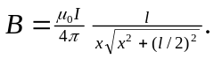 Here all edges produce a field into the page so we can just add them up:
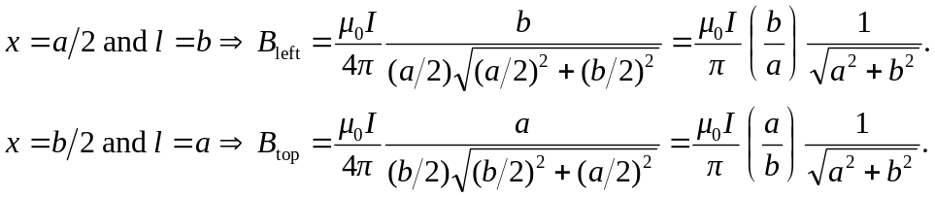
And the right and bottom edges just produce the same contribution as the left and top, respectively. Thus the total magnetic field is:

